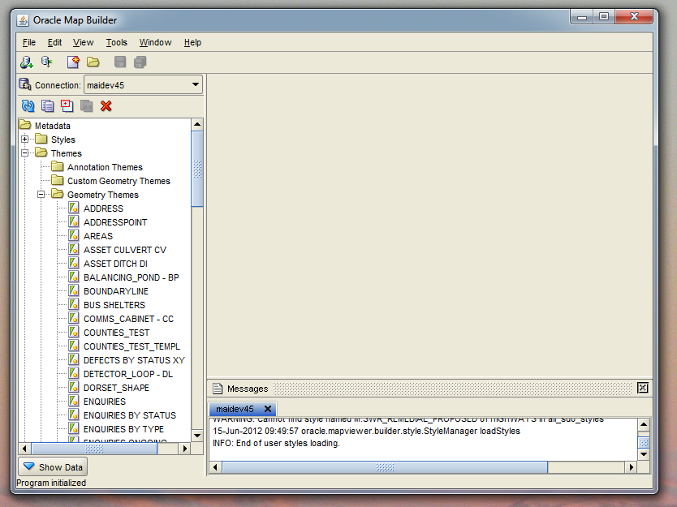

Start Mapbuilder and log into the database.

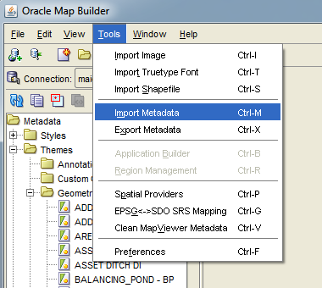

From the menu select tools->Import Metadata

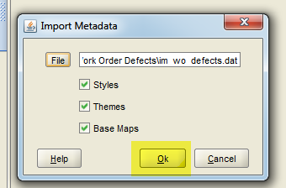

Select the im_wo_defects.dat file

And press ok

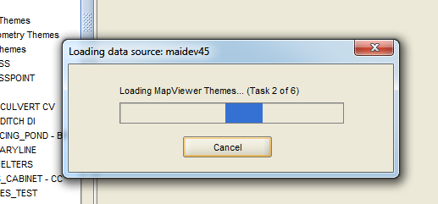

The theme will then be loaded

Mapviewer will need to be restarted for the layer to be visible.

Start a sqlplus session and log on as the highways owner

Run the wo_defects_on_map.sql file.

SQLPLUS>start wo_defects_on_map.sql

This will create a log file. Please check for errors.

Copy the wo_defects_on_map.js file to the im_framework\js directory